Candidate Name:- ROHITHGOWDA V

Superset ID:-6430364

Mail ID:- [rohith2005v@gmail.com](mailto:rohith2005v@gmail.com)

**WEEK – 1 HANDS ON EXERCISE (JAVA FSE DEEPSKILLING)**

**(DESIGN PATTERN AND PRINCIPLES)**

**Exercise 2: Implementing the Factory Method Pattern**

**Scenario:**

You are developing a document management system that needs to create different types of documents (e.g., Word, PDF, Excel). Use the Factory Method Pattern to achieve this.

**Steps:**

1. **Create a New Java Project:**
   * Create a new Java project named **FactoryMethodPatternExample**.
2. **Define Document Classes:**
   * Create interfaces or abstract classes for different document types such as **WordDocument**, **PdfDocument**, and **ExcelDocument**.
3. **Create Concrete Document Classes:**
   * Implement concrete classes for each document type that implements or extends the above interfaces or abstract classes.
4. **Implement the Factory Method:**
   * Create an abstract class **DocumentFactory** with a method **createDocument()**.
   * Create concrete factory classes for each document type that extends DocumentFactory and implements the **createDocument()** method.
5. **Test the Factory Method Implementation:**
   * Create a test class to demonstrate the creation of different document types using the factory method.

**Code for the above question:-**

import java.util.*;

class FactoryMethodPatternExample {

public static void main(String[] args) {

DocumentFactory wordFactory = new WordDocumentFactory();

DocumentFactory pdfFactory = new PdfDocumentFactory();

DocumentFactory excelFactory = new ExcelDocumentFactory();

Document wordDoc = wordFactory.createDocument();

Document pdfDoc = pdfFactory.createDocument();

Document excelDoc = excelFactory.createDocument();

wordDoc.open();

pdfDoc.open();

excelDoc.open();

}

}

interface Document {

void open();

}

class WordDocument implements Document {

public void open() {

System.out.println("Opening a Word document.");

}

}

class PdfDocument implements Document {

public void open() {

System.out.println("Opening a PDF document.");

}

}

class ExcelDocument implements Document {

public void open() {

System.out.println("Opening an Excel document.");

}

}

abstract class DocumentFactory {

public abstract Document createDocument();

}

class WordDocumentFactory extends DocumentFactory {

public Document createDocument() {

return new WordDocument();

}

}

class PdfDocumentFactory extends DocumentFactory {

public Document createDocument() {

return new PdfDocument();

}

}

class ExcelDocumentFactory extends DocumentFactory {

public Document createDocument() {

return new ExcelDocument();

}

}

**Output:-**

Opening a Word document.

Opening a PDF document.

Opening an Excel document.

=== Code Execution Successful ===

**Output Image:-**

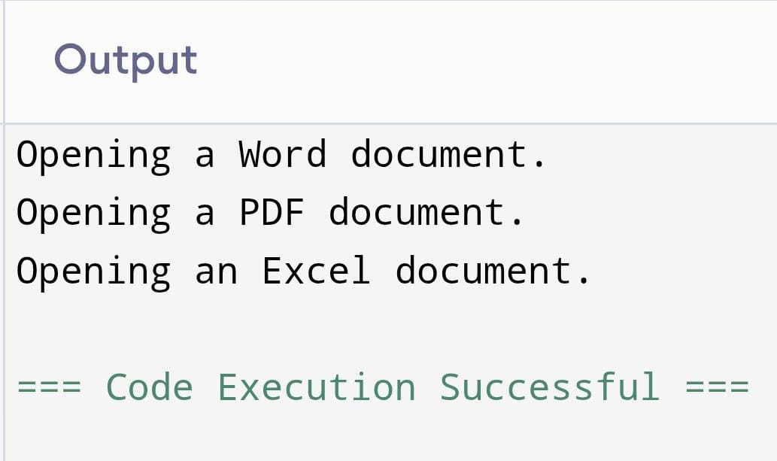

**(DESIGN PATTERN AND PRINCIPLES)**

**Exercise 1: Implementing the Singleton Pattern**

**Scenario:**

You need to ensure that a logging utility class in your application has only one instance throughout the application lifecycle to ensure consistent logging.

**Steps:**

1. **Create a New Java Project:**
   * Create a new Java project named **SingletonPatternExample**.
2. **Define a Singleton Class:**
   * Create a class named Logger that has a private static instance of itself.
   * Ensure the constructor of Logger is private.
   * Provide a public static method to get the instance of the Logger class.
3. **Implement the Singleton Pattern:**
   * Write code to ensure that the Logger class follows the Singleton design pattern.
4. **Test the Singleton Implementation:**
   * Create a test class to verify that only one instance of Logger is created and used across the application.

**Code for the above question:-**

import java.util.*;

public class SingletonPatternExample {

public static void main(String[] args) {

Logger logger1 = Logger.getInstance();

logger1.log("First message.");

Logger logger2 = Logger.getInstance();

logger2.log("Second message.");

if (logger1 == logger2) {

System.out.println("Both references point to the same Logger instance.");

} else {

System.out.println("Different Logger instances.");

}

}

}

class Logger {

private static Logger instance;

private Logger() {

System.out.println("Logger instance created.");

}

public static Logger getInstance() {

if (instance == null) {

instance = new Logger();

}

return instance;

}

public void log(String message) {

System.out.println("Log: " + message);

}

}

**Output:-**

Logger instance created.

Log: First message.

Log: Second message.

Both references point to the same Logger instance.

=== Code Execution Successful ===

**Output Image:-**

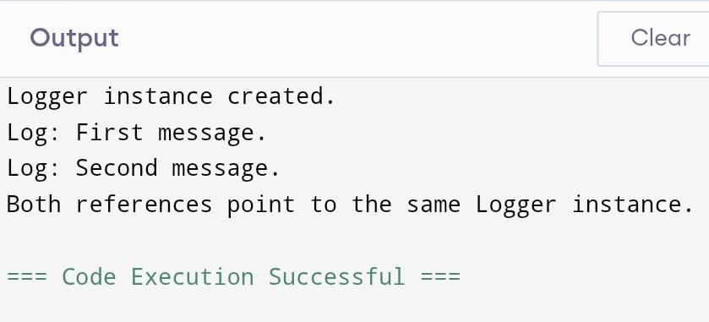

**(ALGORITHM DATA STRUCTURES)**

**Exercise 2: E-commerce Platform Search Function**

**Scenario:**

You are working on the search functionality of an e-commerce platform. The search needs to be optimized for fast performance.

**Steps:**

1. **Understand Asymptotic Notation:**
   * Explain Big O notation and how it helps in analyzing algorithms.
   * Describe the best, average, and worst-case scenarios for search operations.
2. **Setup:**
   * Create a class **Product** with attributes for searching, such as **productId, productName**, and **category**.
3. **Implementation:**
   * Implement linear search and binary search algorithms.
   * Store products in an array for linear search and a sorted array for binary search.
4. **Analysis:**
   * Compare the time complexity of linear and binary search algorithms.
   * Discuss which algorithm is more suitable for your platform and why.

**Code for above question:-**

import java.util.*;

public class ECommerceSearch {

public static void main(String[] args) {

Product[] products = {

new Product(103, "Laptop", "Electronics"),

new Product(101, "Shirt", "Apparel"),

new Product(105, "Headphones", "Electronics"),

new Product(102, "Book", "Education"),

new Product(104, "Shoes", "Footwear")

};

System.out.println("Linear Search:");

Product result1 = linearSearch(products, 102);

if (result1 != null) {

System.out.println("Found: " + result1);

} else {

System.out.println("Product not found.");

}

Arrays.sort(products);

System.out.println("Binary Search:");

Product result2 = binarySearch(products, 104);

if (result2 != null) {

System.out.println("Found: " + result2);

} else {

System.out.println("Product not found.");

}

}

public static Product linearSearch(Product[] products, int id) {

for (Product product : products) {

if (product.productId == id) {

return product;

}

}

return null;

}

public static Product binarySearch(Product[] products, int id) {

int left = 0;

int right = products.length - 1;

while (left <= right) {

int mid = left + (right - left) / 2;

if (products[mid].productId == id) {

return products[mid];

} else if (products[mid].productId < id) {

left = mid + 1;

} else {

right = mid - 1;

}

}

return null;

}

}

class Product implements Comparable<Product> {

int productId;

String productName;

String category;

public Product(int productId, String productName, String category) {

this.productId = productId;

this.productName = productName;

this.category = category;

}

public String toString() {

return productId + " - " + productName + " (" + category + ")";

}

public int compareTo(Product other) {

return Integer.compare(this.productId, other.productId);

}

}

**Output:-**

Linear Search:

Found: 102 - Book (Education)

Binary Search:

Found: 104 - Shoes (Footwear)

=== Code Execution Successful ===

**Output Image:-**

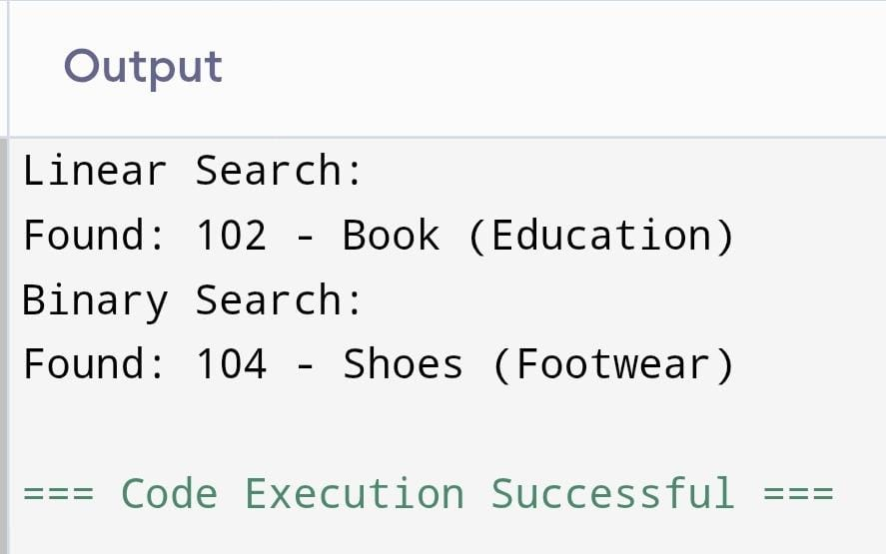

**(ALGORITHM DATA STRUCTURES)**

**Exercise 7: Financial Forecasting**

**Scenario:**

You are developing a financial forecasting tool that predicts future values based on past data.

**Steps:**

1. **Understand Recursive Algorithms:**
   * Explain the concept of recursion and how it can simplify certain problems.
2. **Setup:**
   * Create a method to calculate the future value using a recursive approach.
3. **Implementation:**
   * Implement a recursive algorithm to predict future values based on past growth rates.
4. **Analysis:**
   * Discuss the time complexity of your recursive algorithm.
   * Explain how to optimize the recursive solution to avoid excessive computation.

**Code for above question:-**

import java.util.Scanner;

public class FinancialForecasting {

public static double forecast(double initial, double rate, int years) {

if (years == 0) {

return initial;

}

return forecast(initial, rate, years - 1) * (1 + rate);

}

public static void main(String[] args) {

Scanner scanner = new Scanner(System.in);

System.out.print("Enter initial amount: ");

double initial = scanner.nextDouble();

System.out.print("Enter annual growth rate (e.g., 0.05 for 5%): ");

double rate = scanner.nextDouble();

System.out.print("Enter number of years: ");

int years = scanner.nextInt();

double futureValue = forecast(initial, rate, years);

System.out.printf("Future value after %d years: %.2f\n", years, futureValue);

}

}

**Input:-**

Enter initial amount: 10000

Enter annual growth rate (e.g., 0.05 for 5%): 0.07

Enter number of years: 5

**Output:-**

Future value after 5 years: 14025.52

=== Code Execution Successful ===

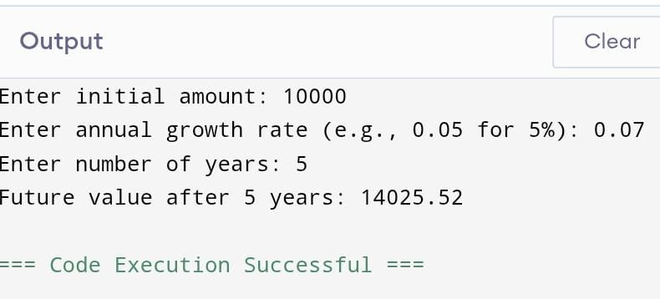**Output Image:-**